**Chocoholics Anonymous**



***Use Case Specification Document***

**02**

**Provider Payment**

**Version No. 1.0**

**Project Document Revision History**

|  |  |  |  |
| --- | --- | --- | --- |
| **VersionNumber** | **Date** | **Revision Author** | **Description of Revision** |
| 1 | 06/07/2019 | Vaishali Jain | Initial Version |
| 2 | 7/17/2019 | JessRose Narsinghia | July Revision |

|  |
| --- |
| **Table of Contents** |

Introduction 3

Use Case Information 4

Actors 4

Use Case Interaction 4

Trigger 4

Pre-condition(s) 4

Post-condition(s) 4

Use Case Swimlane (Activity) Diagram 5

Main/Basic Flow(s) of Events (Happy Path) 5

Alternate/Exception Flow of Events 6

Assumptions/Business Rules including Non-Functional Requirements 6

Use Case Specification Review and Signoff **6**

# 

# Introduction

This Use Case highlights Chocoholic Anonymous health care providers payment process. Every week based on the total number and type of services performed, the ChocAn provider receives payments. The ChocAn Data enter writes records of these amounts to a disk which then is read by the EFT component. This action initiates EFT money transfers to providers’ respective accounts. ~~The provider gets weekly payment of amount calculated by the total number and type of services he/she has performed for the week. The Chocoholics Anonymous Data center write the record of all the providers payments details for the week on the disk, the EFT component then reads that data from the disk and initiate an EFT money transfer to credit the providers account respectively.~~

# **Use Case Information**

## Actors

An actor is someone or something (e.g. application system) outside the system or business that interacts with the application. For every Use Case, there must be at least one Main Actor and zero or more Secondary Actors. Actors should be a person, system, or time.

|  |  |  |
| --- | --- | --- |
| **Actor Name** | **Role** | **Description** |
| EFT | Main | Initiates the payment by providing EFT funds transfer every friday at midnight. |
| Time | Main | Triggers the EFT component every friday at midnight to start the payment process |
| Provider | Secondary | Provider gets the money on his/her bank account |
| System | Secondary | Keeps record of the provider and its payment information to be picked by the EFT component |

## **Use Case Interaction**

**Predecessor :** Report Generation- ( Use-Case 04) - After the provider report is generated , the report is read by the EFT to initiate the payment transfer.

**Successor :** None

# Trigger

Time Triggers the EFT component on every friday at midnight to start the payment process.

# **Pre-condition(s)**

Below are the preconditions required for providers payment process:

* 1. The report containing provider ID and amount to be paid must be present before the EFT initiates payment.
  2. Provider bank details must be available in the EFT system to credit the account

# **Post-condition(s)**

Possible outputs on completion are listed below :

* 1. Providers bank account credited by the amount calculated based on the work done by him that week.

# **Use Case Swimlane (Activity) Diagram**

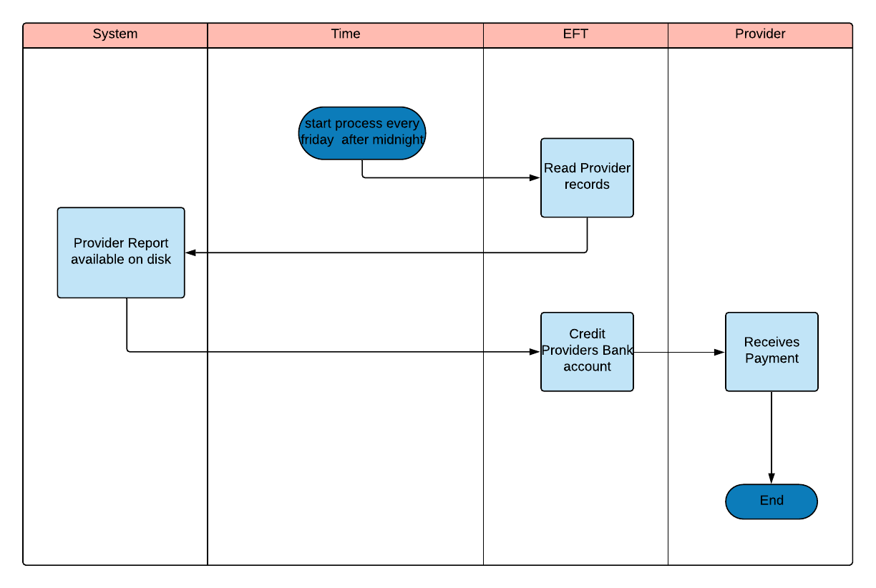

# **Main/Basic Flow(s) of Events (Happy Path)**

* 1. **Provider Receives Payment :**

1. ChocoAn DataCenter system generates provider report including provider id and amount to be paid
2. The reports generated are written on the disk/system
3. At~~After~~ Midnight on friday the EFT component is triggered to read the data from the ChocoAn DataCenter System.
4. EFT credits providers bank account with the payment amount

# Alternate/Exception Flow of Events

* 1. No Data Present on the ChocoAn DataCenter System.
  2. Error processing EFT transaction

# Assumptions/Business Rules including Non-Functional Requirements

We are assuming that the provider’s information is available with the bank and these is no issue in the EFT process.

# **Use Case Specification Review and Signoff**

|  |  |  |  |  |
| --- | --- | --- | --- | --- |
| **Review and Signoff of the Use Case Specification** | | | | |
| **Name** | **Project Team Role** | **Signature** | **Date** | |
| Tejaswi Dasyam | Team Member | tejaswi | 06/11/2019 | |
| Vaishali Jain | Team Member | vaishalijain | 06/11/2019 | |
| Khushmeet Kaur | Team Member | khushmeetkaur | 06/11/2019 | |
| Mohanapriya Kottan Rajaraman | Team Member | Mohanapriya | 6/11/2019 | |
| Kopal Shinde | Team Lead | kopal | 6/11/2019 | |